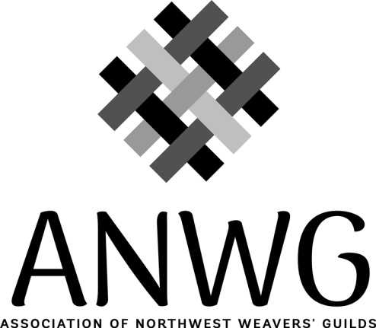

ANWG PROXY FORM

If no one from your Guild is able to attend the Annual Membership Meeting you may designate a representative or alternate (a proxy) from another Guild to attend the meeting on your behalf. You are encouraged to do this so we will have a quorum at the Annual Membership Meeting.
Use this form only if appointing a proxy from another ANWG member guild. You do not need a proxy if another member of your Guild is attending instead of the Guild’s ANWG Representative.

ASSOCIATION OF NORTHWEST WEAVERS' GUILDS
Date: _______________________________________________________________
We the undersigned, as a Member Guild of the Association of Northwest Weavers’ Guilds do hereby appoint:
Name of the person you are giving your vote to:
____________________________________________________________
Name of the Guild that they are a member of:
_______________________________________________________________
To act as proxy for
______________________________________________________________
(The name of your Guild)
My/Our proxy will have the powers we would possess if personally present, and to attend, vote and to act on my/our behalf at the AMM on June 14, 2019.
Signature of Guild President or Representative:
_______________________________________________________________

PLEASE NOTE: Complete and return this form to the secretary by May 10, 2019.
Send completed form to: Melanie Smith, ANWG Secretary,
523 S. Pond St. Boise, ID 83705 USA
Or scan and email this completed form to: yarnsnthreads@aol.com.

