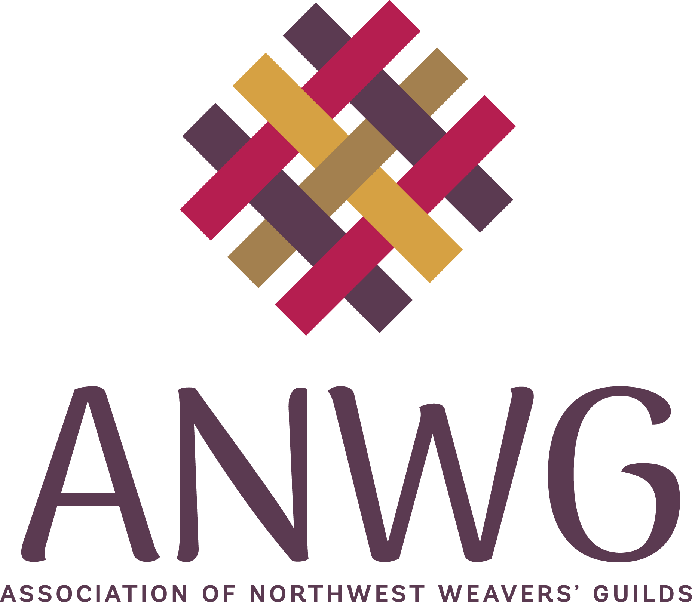
ANWG Creative Challenge Grant Application

Name of Guild:
Mailing Address:
Number of Members:

President:
Mailing Address:
Email:
Phone:

Names and email addresses of the people responsible for the project:
1.
2.
3.

Name of Project:

What need does your project address or how does this promote fiber arts?

How will your project meet that need/promoting fiber arts?

Please describe in full the activities that will be undertaken to successfully complete the project. If this is a workshop/seminar event, please give the name of the instructor and a brief bio or artist’s website.

Who will benefit from the activities for which you are seeking a grant? This includes the number of active participants as well as any broader community involvement and outreach.

Will this project activity/event be available to other ANWG members?

Do you intend to list/advertise the event on the ANWG website?

Income and Expense Grant Project Budget
Guild Name: ____________________________________________________

Projected Income |  | Projected Expenses
ANWG grant, US$: | $ 600.00 | Facility rental:  Equipment rental: | $
Attendee fees:  # @ $ per person  # @ $ per person |  | Instructor(s) fees:  Instructor(s) Name(s):
Other sources of income: |  | Instructor(s) travel/meal/lodging expense:
Monetary or In-Kind Donations: (please list in detail) |  | Other costs: (please list in detail)
Guild funds: |  | Advertising:
 |  | Food:
Total Projected Income: | $ | Total Projected Expenses: | $

Please email this (scanned) signed page and the completed application as a word.doc to The ANWG Education Chair at education@northwestweavers.org, or directly to l.moncrief@me.com no later than April 15, 2026.

_________________________________________ ______________________________
Signed: Guild President Date

_________________________________________ ______________________________
Signed: Project Chair, if appropriate Date

