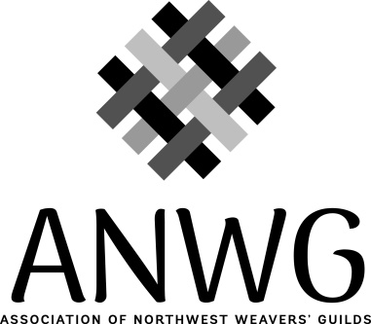
2022 - 2023 ANWG Grant Application

Name of Guild:
Mailing Address:
Number of Members:

President:
Mailing Address:
Email:
Phone:

Names and email addresses of the people responsible for the project:
1.
2.
3.

Name of Project:

What need does your project address or how does this promote fiber arts?

How will your project meet that need/promoting fiber arts?

Please describe in full the activities that will be undertaken to successfully complete the project. If this is a workshop/seminar event, please give the name of the instructor and a brief bio or artist’s website.

Who will benefit from the activities for which you are seeking a grant? This includes the number of active participants as well as any broader community involvement and outreach.

Will this project activity/event be available to other ANWG members?

Do you intend to list/advertise the event on the ANWG website?

If you have an event or workshop already scheduled in 2022 or 2023, you can apply awarded grant funds to that scheduled event. Please complete the application and budget for that event.

Income and Expense Grant Project Budget
Guild Name: ____________________________________

Projected Income |  | Projected Expenses
ANWG grant, US$ | $ 600. | Facility rental:  Equipment rental: | $
Attendee fees:  # @ $ per person  # @ $ per person |  | Instructor(s) fees:  Name:
Other sources of income: |  | Instructor travel/meal/lodging expense:
Donations:  In Kind  Monetary |  | Other costs: (please list in detail)
Guild funds: |  | Advertising
 |  | Food
Total Projected Income: | $ | Total Projected Expenses: | $

Please email this (scanned) signed page and the completed application as a word.doc to 2VP@northwestweavers.org no later than November 1, 2021.

_________________________________________ ______________________________
Signed: Guild President Date

_________________________________________ ______________________________
Signed: Project Chair, if appropriate Date

